May 2022  Mass Schedule  SATURDAY  11am in Coliseum  Fr Pat Iannotti  Confession at 10:30  SUNDAY  9:30am in Coliseum  Fr Giorgio  Confessions 8:30-9:15  12pm Latin Mass  Begins May 29  in Martyrs Chapel  Fr Brian Slezak  MON-FRI  11am Mass in Coliseum  Fr Giorgio  Confessions 10-10:45  3pm Eucharistic Adoration  In Coliseum with  Divine Mercy Chaplet &  Seven Sorrows of Mary  5pm Rosary in Coliseum  Gift Shop 518.853.3939  Daily 10am-3pm  Museum: 518.336.5694  Daily 10:30am-3:30pm  EVENTS  Fri May 6  Fulton County Confirmation  6:30pm Mass in Coliseum  Celebrant:  Bishop Scharfenberger  Sat May 14  RCDA Scouts Retreat  Ron parish@nycap.rr.com  7pm Mass open to public  Bishop Scharfenberger  Sun May 22  May Crowning at  9:30 Mass  Cont.’ on back. . .  Sun May 29  Reception in Visitor Center after 9:30 Mass for  Fr Giorgio’s 10th Anniversary of Ordination (May 26)  Sat June 18  12pm Reception in  Visitor Center  For Fr Pat Iannotti’s  90th Birthday  Fri, Sat, Sun June 24,25,26  40 Hours Eucharistic Devotion  Contact and Schedule TBA  July 6-14  St Kateri Novena of Masses  11am Mon-Sat. 9:30 Sunday  Sat July 9  Catholic Lawyers & Medical  Guild Conference  12-4pm in Visitor Center  4pm Mass, Celebrant:  Bishop Scharfenberger  Aug 7-14  Assumption Novena of Masses  11am Mon-Sat, 9:30 Sun  Sat Aug 20  Step Up! Men’s Conference  With Fr Donald Calloway, MIC  And Fr Roger Landry  4pm Mass  Rcda.org/StepUp  Aug 28  Polish Pilgrimage  Stations, Confessions,  3pm Mass in Coliseum  Pot Luck in Pavilion  315.5.601.1968  Tomaz tommro@verizon.net  More Events to Come! | Shrine of our Lady of Martyrs  Auriesville, New York  The Holy Ground of the North American Martyrs  and Birthplace of St. Kateri Tekakwitha
Welcome, Father Giorgio!
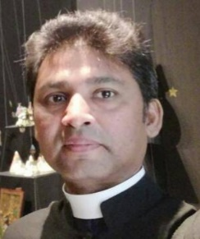
The Shrine is overjoyed to welcome visiting priest, Rev. Varghese Mangalath Thoman, most affectionately known as Father Giorgio. He is from Kerala on the Malabar Coast of southern India.

In Italy, he studied for the priesthood in Alessandria, was ordained in Asti on May 26, 2012, and has been incardinated in the Asti Diocese for his entire priesthood. He served at St. Rita’s Shrine, St. Padre Pio Shrine, and is a parish priest at St. Bernard Parish in the province of Turin. He frequently prays at the Cathedral of St. John the Baptist where the Holy Shroud of Turin resides. He has also served as a hospital chaplain.

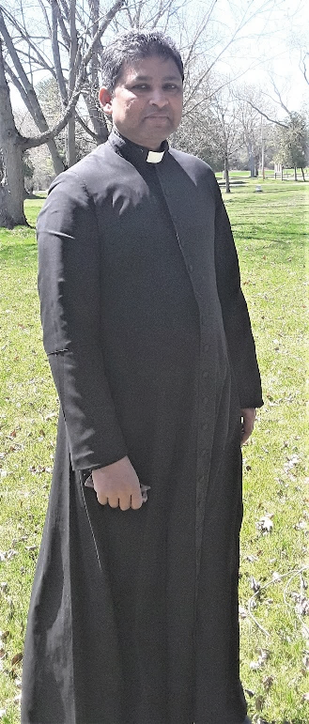
Father Giorgio is a joyful presence here, walking the holy grounds in his cassock, greeting and praying with pilgrims. In addition to Sunday Mass, he is offering weekday Masses and Adoration (see sidebar at left), will participate in the Annual Martyrs Mini Retreat, and will offer an Italian Pilgrimage Mass (dates for both TBA).

During his May through July ministry with us this year, he is eager to serve God and offer the mercy and healing of Jesus to all.

There will be a reception in the Visitor Center for Father after Mass on Sunday May 29, in celebration of his 10th Anniversary of Ordination (May 26). All are welcome!

Friends of Our Lady of Martyrs Shrine, 136 Shrine Rd, Fultonville, NY 12072
518-853-3939 info@ourladyofmartyrsshrine.org www.ourladyofmartyrsshrine.org FB: Auriesville Shrine
Owned & operated by Friends of Our Lady of Martyrs Shrine, Inc., a not-for-profit organization in fidelity to the Magisterium of the Catholic Church.

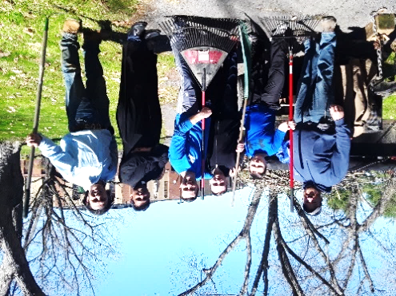
The Knights of Columbus Our Lady of Martyrs Council continues to organize clean up days at the Shrine, in conjunction with the Glenville Council. If you missed K of C Columbia Magazine, March issue, here is a link to Knights clearing undergrowth on the Hill of Torture.
https://issuu.com/columbia-magazine/docs/columbiamar22en

Photo above is part of the crew on April 30 with the fourth haul of downed branches after high winds and heavy snows. L to R: Greg Biggins of Glenville Knights; Fred Ziegler, his brother William, their father Patrick from Glenville Knights; Father Giorgio, and Eric Mazzone, Our Lady of Martyrs Council.
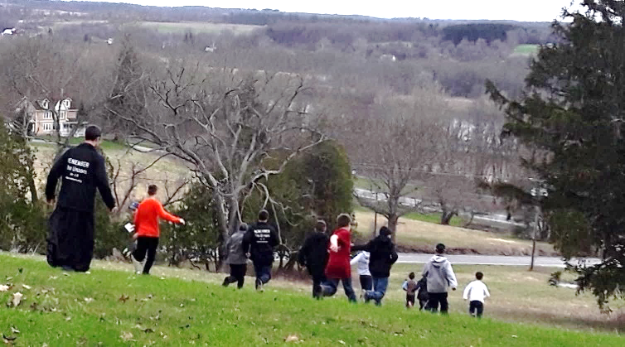
A few pilgrimages came early and the braved the wind and cold. Brothers and altar servers from St Benedict Monastery in Fall River, MA, spent the day on the grounds, museum, ravine. They were invited to experience the Hill of Torture and took a lively run down, and slower run back up.

Catholic Campus Ministry from the University of Missouri journeyed a long way to learn about the Auriesville Saints here at the Shrine and at the Kateri Shrine in Fonda. Their expressions and questions revealed how moved they were with each step on the holy ground and each chapter of the story.

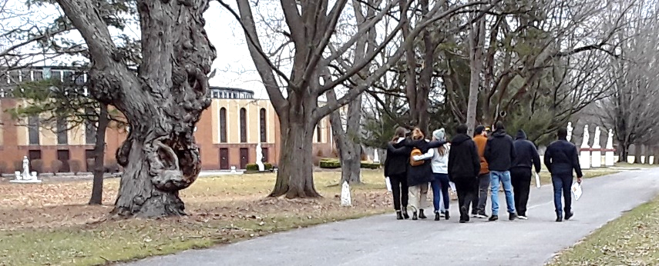

See what is new in the Gift Shop -more books! – and comfy furniture where pilgrims can sit and peruse. A new exhibit in the Saints of Auriesville Museum introduces pilgrims to some Native American Catholics, including those whose cause for sainthood is open. The Kateri Chapel is now open every day for private prayer.

Join us in thankful praise to God for the blessings bestowed upon the Shrine and for his continued guidance and grace. Saints of Auriesville, pray for us! Our Lady of Martyrs, pray for us! Jesus, King of Martyrs, show us the way!

